Architecture Document

# Introduction

## Purpose

This document provides a brief description of coding exercise in which a single sample file is processed into a database

## Description

This application is designed for a narrow coding exercise in which a single sample data file would be read in from the file system, processed from JSON into object models then placed into an in-memory database.

# Development View

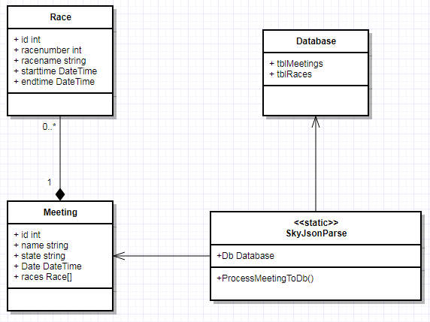

# Use-Case View

## Main Use-case

This use case allows the user to run the application to process the SampleData.json file in the same directory. It runs until the file has competed process and the application awaits user input to exit. The user is an actor in this use case.

# Logical View

## Application

Application is a Console Application with no UI. Error messages are displayed to console if required.

## Business Services

The applications parse of the file will be kept in object models defined in development view.

## Middleware

The application has access to an in-memory database that houses the stored results.